**World Vision Playful Parenting Resources for ECD**

**[Toy Guide for Early Childhood Development (Ages 0-6)](https://www.wvi.org/publications/manualtoolkit/world-vision-toy-guide-early-childhood-development-version-1) - This booklet contains instructions for parents and caregivers to make simple toys for children 0-6 years. The booklet also includes ideas for engaging young children with those toys and games. The toys and activities promote development across four domains: literacy, numeracy, physical, and socio-emotional.

The resource is picture-based and suitable for low- /no literacy levels. The resource can be sent over Whatsapp or other digital platforms as an e-booklet, or printed and provided in hard copy. This resource can be provided by community leaders or cadres such as faith leaders or Community Health Workers that are trusted by caregivers. These cadres can then follow up with supportive phone calls as needed.

There are three versions of the booklet to ensure that it is appropriate across multiple cultural contexts and translations exist in Arabic, French, Spanish and Lao.

*Please review each version to determine which is most reflective of your audience.* <https://www.wvi.org/publications/manualtoolkit/world-vision-toy-guide-early-childhood-development-version-1>

**Costs-**

* Short virtual training for cadres
* Stipend or incentive for cadres (if required)
* Translation
* Data to send as e-booklet
* Coloured printing (if providing as hard copy)
* Distribution (if providing as hard copy)

**[Playful Parenting Activity Booklet (Ages 0-6)](https://www.wvi.org/publications/manualtoolkit/playful-parenting-activity-booklet-version-1) - This booklet contains ideas for parents and caregivers to help support their young child's physical, cognitive and social-emotional development. The booklet includes specific ideas for children from 0-6 and is broken into helpful sections based on a young child's developmental milestones.

The resource is picture-based and suitable for low- /no literacy levels. The resource can be sent over Whatsapp or other digital platforms as an e-booklet, or printed and provided in hard copy. This resource can be provided by community leaders or cadres such as faith leaders or Community Health Workers that are trusted by caregivers. These cadres can then follow up with supportive phone calls as needed.

There are six versions of the booklet to ensure that it is appropriate across multiple cultural contexts and translations exist in Arabic, French and Spanish.

*Please review each version to determine which is most reflective of your audience.* <https://www.wvi.org/publications/manualtoolkit/playful-parenting-activity-booklet-muslim-contexts-version-1>

**Costs-**

* Short virtual training for cadres
* Stipend or incentive for cadres (if required)
* Translation
* Data to send as e-booklet
* Coloured printing (if providing as hard copy)
* Distribution (if providing as hard copy)

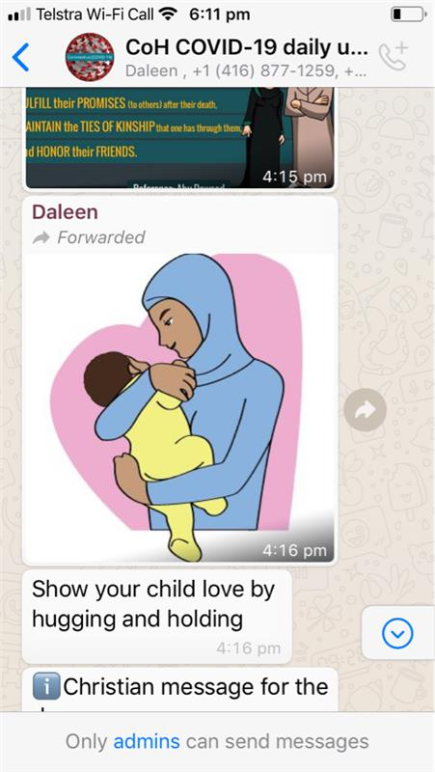Whatsapp Playful Parenting Messages-

Images developed for the Playful Parenting booklet can be utilised to send simple digital messages via Whatsapp or other platforms to caregivers as daily reminders to engage with their children to promote development. Messages can be sent to community leaders or cadres that are trusted by caregivers. These cadres can then translate text into local languages as required and forward on the messages to those caregivers they have connections with and follow up with supportive phone calls as needed.

**Costs-**

* Short virtual training for cadres
* Data to send messages and make phone calls
* Stipend or incentive for cadres (if required)

**If you would like editable files allowing translation or images to be used for Whatsapp messages please contact** [**education@wvi.org**](mailto:education@wvi.org)