Guiding framework and structure of the tool
Strategic planning for developing or strengthening pre-primary systems or subsectors requires systematic analysis, which can be a complicated task. UNICEF’s ‘Pre-Primary Subsector Analysis Tool’ is designed to support countries in organizing and streamlining this process.
The tool was developed as a companion to Build to Last: A framework in support of universal quality pre-primary education, which outlines a guiding framework that highlights three fundamental building blocks for an effective pre-primary subsector: (1) five core functions; (2) a supportive or enabling environment; and (3) a set of guiding principles.
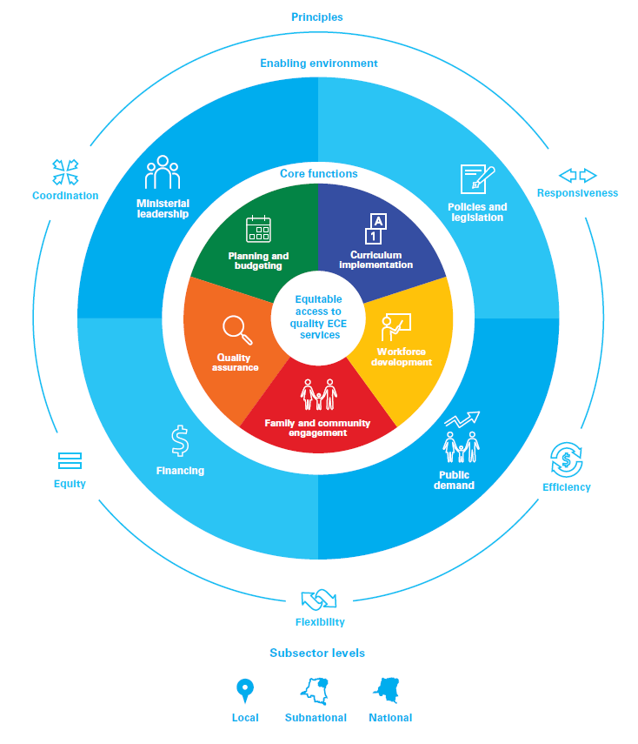
The Tool aims to help national stakeholders assess the strengths and weaknesses of a country’s pre-primary subsector. Using the tool is likely to result in a detailed, practical understanding of the components of each core function and the enabling environment (and how these components interconnect in coherent, powerful ways) – which will make it possible to identify priority areas for planning and action to improve the delivery of quality pre-primary services.
The fundamental purpose is to facilitate reflection and self-assessment on where your country stands regarding each core function and the enabling environment. This tool is not intended to be used for ‘benchmarking’ countries or to give marks on practices. The aim is to raise awareness about key issues, identify any gaps, and move forward to improve areas and processes that can be changed to increase access and deliver high-quality pre-primary programmes.

The tool has six modules, one for each of the five core functions, plus a module on the enabling environment:
Module 1: Planning and budgeting
Module 2: Curriculum development and implementation
Module 3: Workforce development
Module 4: Family and community engagement
Module 5: Quality assurance
Module 6: Enabling environment

Each module begins with a brief description of the core function or key factor in the enabling environment that forms the emphasis of the module, followed by extensive content on:
• Goals that the subsector should prioritize to build a stronger pre-primary system and achieve results for children.
• Measures of progress for each goal, which are intended to encourage self-assessment and reflection, and support monitoring for a pre-primary system.
• Questions that follow the measures and are intended to jump-start dialogue around issues and considerations in achieving progress. These questions are not exhaustive, and some of them may not be relevant to your context. As with all content in this tool, they are designed to be both comprehensive and readily adapted to the circumstances and status of a specific pre-primary system.
Note that questions highlighted in green cover play-based learning aspects, while questions highlighted in turquoise cover equity and inclusion considerations. Content highlighted in yellow is specific to humanitarian considerations. Where there is an overlap between equity and humanitarian considerations, humanitarian information is color-coded turquoise and referred to as an equity consideration.

This tool is an adaptable resource. No matter where your country is in the systems-strengthening process, you will be able to use the subsector analysis tool. The tool’s goals, measures of progress and associated questions will encourage reflection on your country’s strengths and challenges. You are encouraged to adjust the goals and questions to specific contexts and circumstances. Furthermore, each module in the tool can be used on its own or in conjunction with other modules to fit the purpose of your systems-strengthening analysis.

United Nations Children’s Fund, Build to Last: A framework in support of universal quality pre-primary education, UNICEF, New York, February 2020.

