**BELDS Toolkit Section 2 – Additional Resources:**

Template to Support Problem Tree Analysis

**Introduction:** Through the use of the Pre-primary Subsector Analysis Tool, the underlying challenges or root causes of the ECE subsector will emerge. **This template may be helpful to clarify and validate the Pre-primary Subsector Analysis Tool’s results as a group exercise** (it may be as part of the consultative workshop using the Pre-primary Subsector Analysis Tool or as a separate activity). If used in the context of a consultative workshop using the Pre-primary Subsector Analysis Tool, it can be used in conjunction with Activity 3, Activity 5, Activity 6 and Activity 7 of the Suggested activities for the workshop.

This level of clarification and validation may be needed to form consensus on underlying challenges that need to be addressed and to initiate discussions on how to address these underlying challenges (See tool “3.1 Guiding Questions and Tips: Refining, Selecting and Prioritizing ECE Strategies and Developing Corresponding”).

**Template to support problem tree analysis**

You may adapt and use this template to support problem tree analysis exercises in your context.

|  |  |
| --- | --- |
| **What is the problem?** |  |
| **Who is the problem affecting?** |  |
| **Where is the problem happening?** |  |
| **What are the effects of the problem?** |  |
| **Why is the problem happening?**  ***(This is the underlying cause or “root cause” of the ECE problem/issue)*** |  |

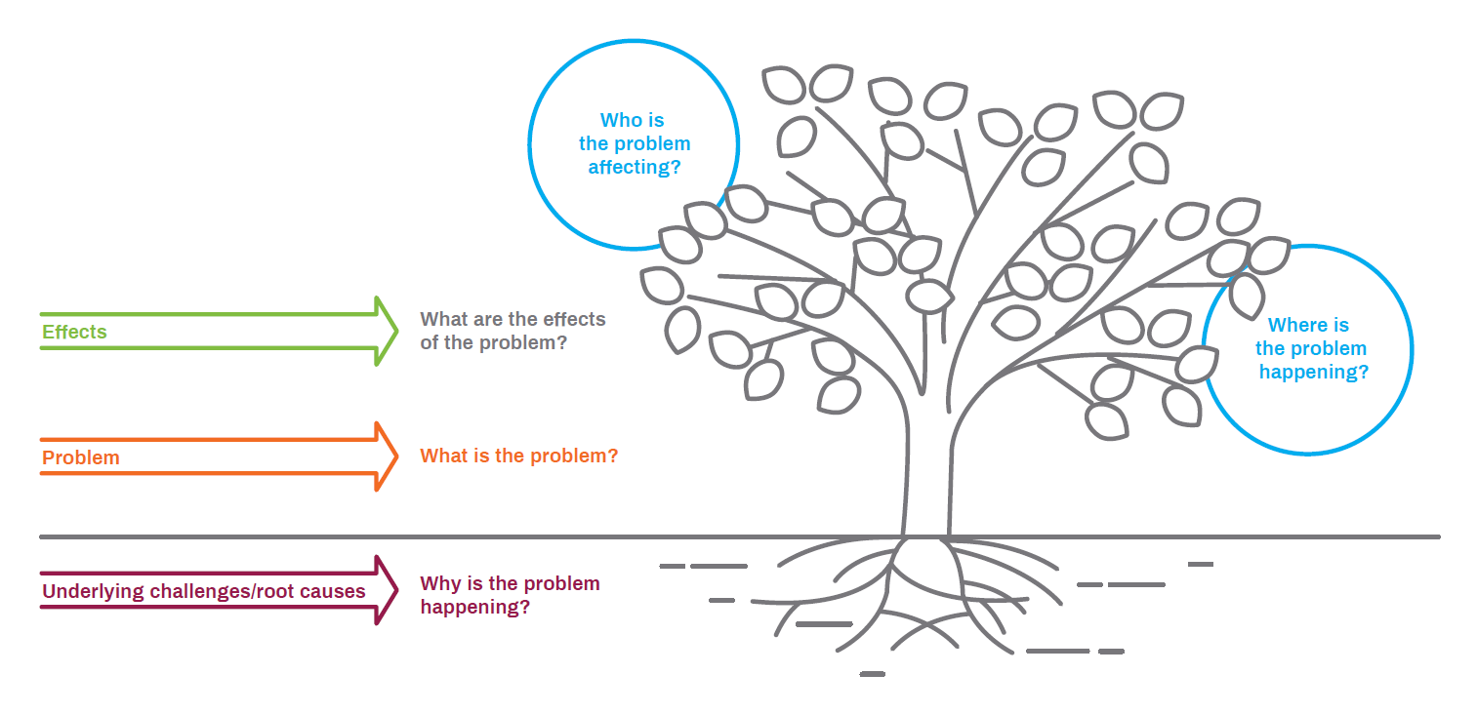

**Proposed steps for a problem tree analysis (using the template)**

**Step1: Describe the problem/issue and identify who it affects and where it is happening**. Problems or challenges may be ECE-specific (ex. low quality of ECE programmes across ECE settings) or associated with the broader system such as, inefficiencies in public expenditures monitoring in education which have direct impact on ECE provision, quality and accountability. It is important to distinguish these in the problem description. The problem description should be based on available data and evidence (see Tool 2.1 ECE Data Mapping and Evidence Plan Spreadsheet and Tool 2.2 Pre-primary Subsector Analysis Tool).

For example, let’s use the problem “**Limited access to pre-school education nationally**”

|  |  |
| --- | --- |
| **What is the problem?** | Limited access to pre-school education nationally |
| **Who is the problem affecting?** | Pre-school age children |
| **Where is the problem happening?** | Nationally |

The example of a problem below cuts across the system but also has an impact on ECE: “Inadequate domestic financing to education – 7% of the national budget”

|  |  |
| --- | --- |
| **What is the problem?** | Inadequate domestic financing to education – 7% of the national budget |
| **Who is the problem affecting?** | All students including ECE students, teachers |
| **Where is the problem happening?** | Nationally |

**Step 2: Identify the effects of the problem**: Effects are the long-term impact of the problem. The effects of a problem often have negative consequences; for example, absence of quality ECE provision may lead to high levels of special education or remediation needs, dependence on social welfare, and crime related cost and incarceration rates. For example, the effects of the problem “**Limited access to pre-school education nationally**” are:

* + High repetition and dropout rates in primary
  + 65% pre-school children out of school
  + Majority of the children going to grade 1 are not school ready

**Step 3: Identify the underlying challenges or root causes of the problem.** Root causes are simply the source/s of a problem, the main reason/s why a problem exists or the main cause that gave rise to the problem. These underlying challenges/root causes will then need to be addressed through the formulation of strategies (which are essentially the “solutions”) – please see Tool 3.1 Refining, Selecting and Prioritizing ECE Strategies and Developing Corresponding Activities.

To identify root causes, it is important to reflect on the below question:*Why is the problem happening?*

The “why” provides the justification for the problem’s existence.For example, why is the problem **“Limited access to pre-school education nationally”** happening? The reasons are:

* Limited public demand
* Limited funding for pre-school
* Pre-school is not free
* Insufficient Pre-school

